F. EXAMPLE PROJECTS WHICH BEST ILLUSTRATE PROPOSED TEAM’S QUALIFICATIONS FOR THIS CONTRACT  (Present as many projects as requested by the agency, or 10 projects, if not specified. Complete one Section F for each project.) |  |  |  |  |  |  | 20. EXAMPLE PROJECT KEY NUMBER  02
21. TITLE AND LOCATION (CITY AND STATE)  Caltrans District 8, Devore Interchange Improvements Design-Build, San Bernardino, CA |  |  |  | 22. YEAR COMPLETED
 |  |  |  | PROFESSIONAL SERVICES  2016 |  |  | CONSTRUCTION (IF APPLICABLE)
23. PROJECT OWNER’S INFORMATION
a. PROJECT OWNER  Caltrans District 8 |  | b. POINT OF CONTACT NAME  Venkatesh Iyer, Ph.D. P.E, Structural Material Representative |  |  | c. POINT OF CONTACT TELEPHONE NUMBER  (858) 967-6363
24. BRIEF DESCRIPTION OF PROJECT AND RELEVANCE TO THIS CONTRACT (INCLUDE SCOPE, SIZE AND COST)

- Field Engineering and Support
- Drainage Systems
- Contract Change Orders negotiations and processing.
- Labor Compliance
- Submittals and RFI’s
- Caltrans Specifications and Manuals
- Day and Night Work
Project Relevance

S2 Engineering provided Source Inspection and IQA services to Caltrans Alternate Delivery Design-Build Project in District 8 in San Bernardino County.
The project limits extended along I-15 from 0.8 miles south of the Glen Helen Parkway undercrossing to 1.4 miles north of the Kenwood Avenue undercrossing, and along I-215 from 1.2 miles south of the Devore Road overcrossing to the I-15 junction. This project eliminated the existing lane reductions on I-15, reduced problems caused by weaving trucks, reduced operational deficiencies at the interchange including non-standard design features, and improved local circulation.
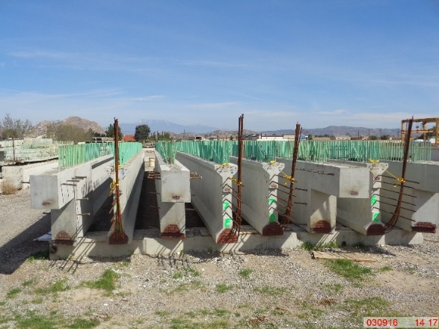
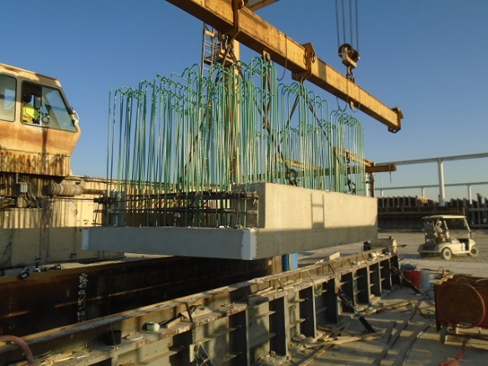
S2’s source inspector worked closely with SMR and ASMR and inspected several complicated bridge structures for this project. S2 maintained daily communication, handled all the on-call assignments, and all reports generated were professional, punctual, skilled, and thorough in their documentation. Caltrans made a request for an experienced and PCI level III Certified Inspector, who handled and inspected complicated bent caps, prestressed girders, pavement slabs and deck panels inspection for this project. Some of the key bridges were:
- Devore Overhead
- Glen Helen Parkway
- Cajon Creek
- Kenwood Avenue
- Glen Helen Road

25. FIRMS FROM SECTION C INVOLVED WITH THIS PROJECT
a. | (1) FIRM NAME  S2 Engineering, Inc. |  | (2) FIRM LOCATION (CITY AND STATE)  Rancho Cucamonga, CA |  |  | (3) ROLE  Source Inspection, AMSR
STANDARD FORM 330 (REV. 7/2021) PAGE 3

